Rental Lead Inquiry Process SOP
Objective
This SOP outlines the step-by-step process for managing rental lead inquiries to ensure efficient handling and communication with prospective tenants.
Key Steps
1. Initial Inquiry Handling 0:00
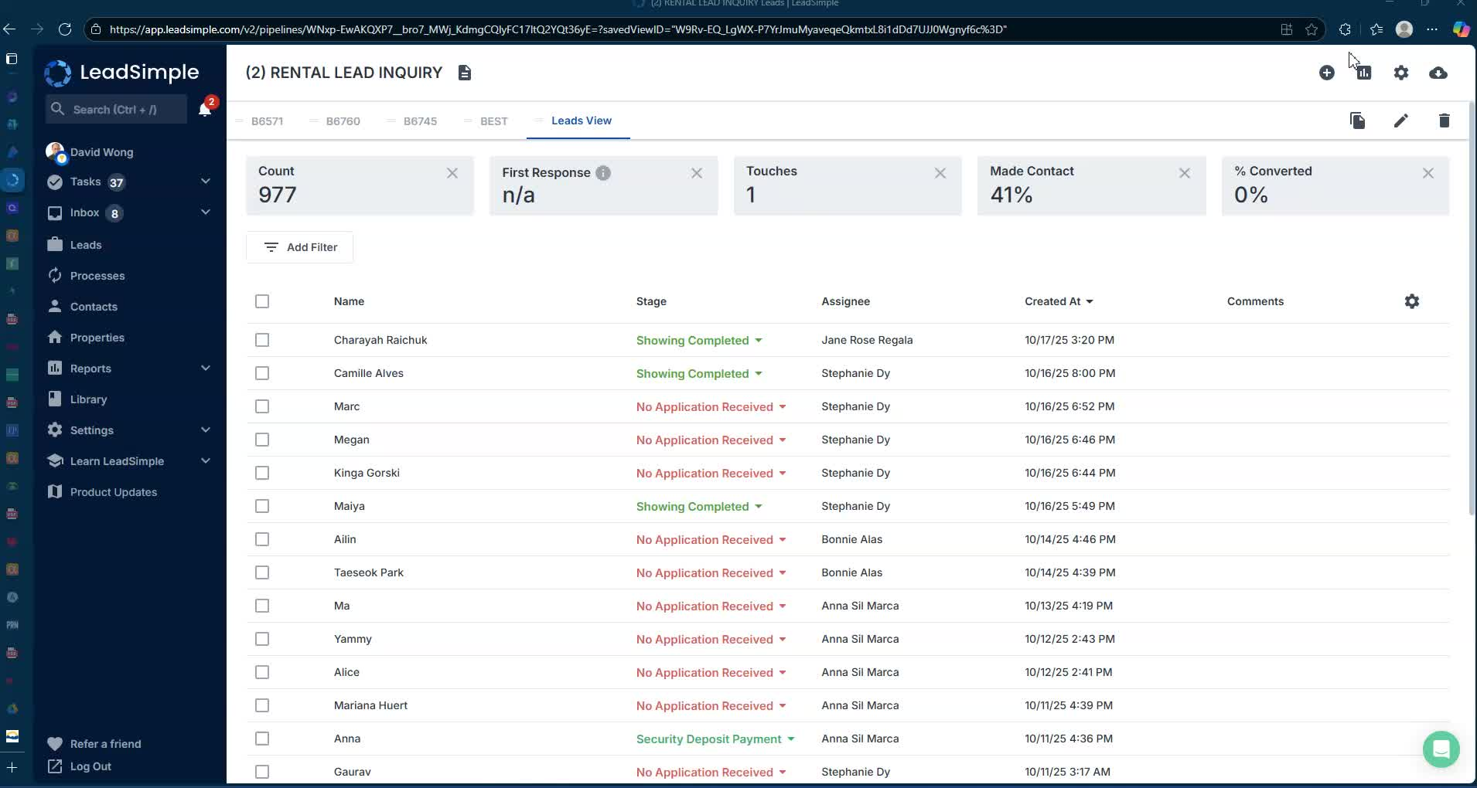
- Funnel Process: Follow the stages of inquiry:
  - Qualify leads
  - Pre-qualify them
  - Schedule showing attendance
  - Handle tenant-occupied vs. vacant properties.
2. Qualifying Leads 1:20
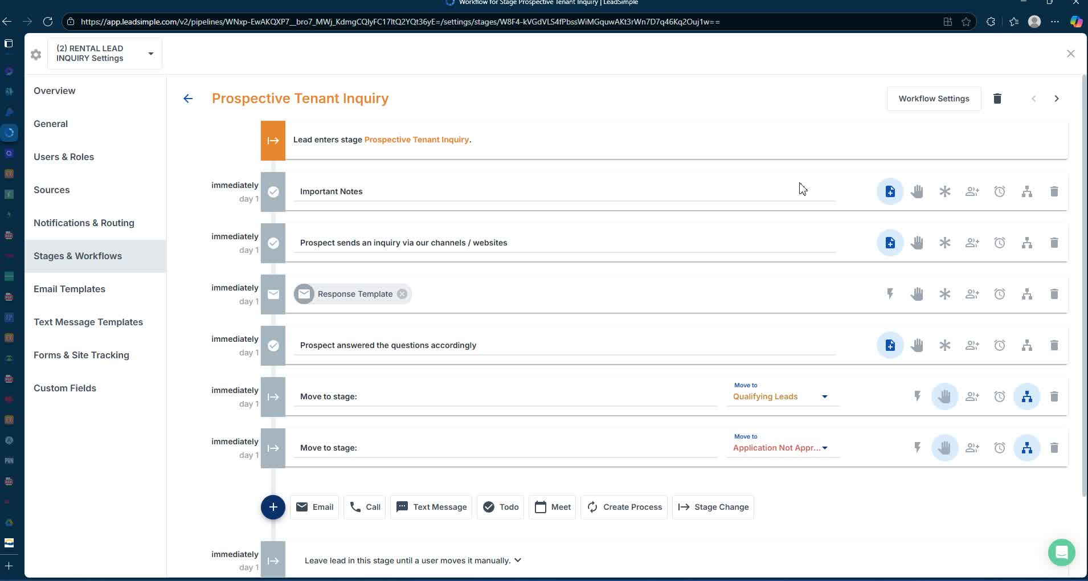
- Response Requirement: Ensure leads answer two questions:
  - How many people will live with you?
  - What are your occupations?
3. Pre-Qualification 2:09
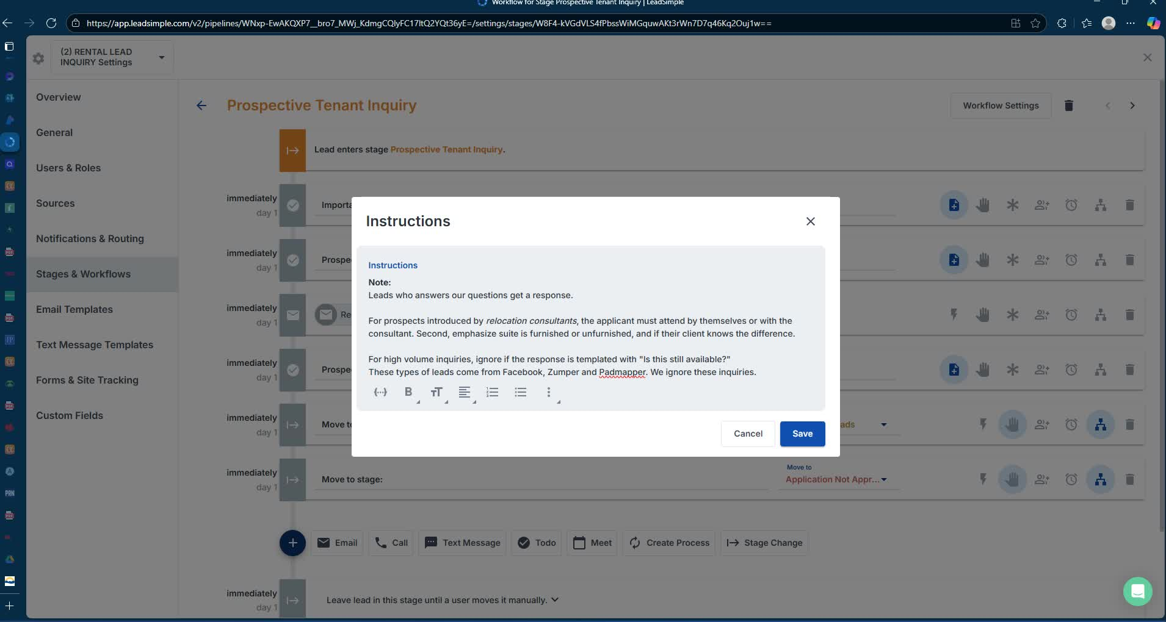
- Introduce Prospects: Ensure prospects are introduced by relocation consultants or pre-screened.
- Attendance Requirement: Applicants must attend showings themselves or with a consultant.
4. Responding to Inquiries 5:08
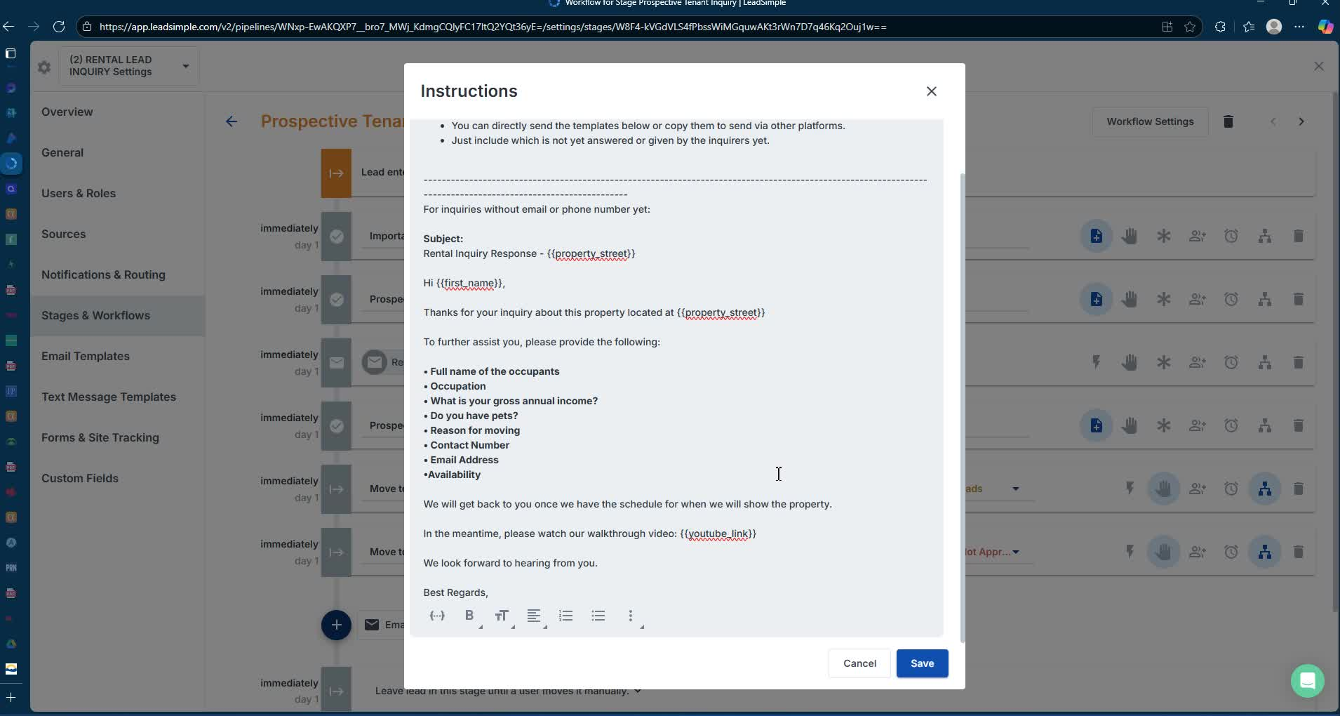
- Read Responses: Always read the prospect's inquiry response before replying.
- Key Questions to Ask:
  - Names of applicants
  - Occupation
  - Pet ownership
  - Reason for moving
  - Contact information.
5. Scheduling Showings 10:00
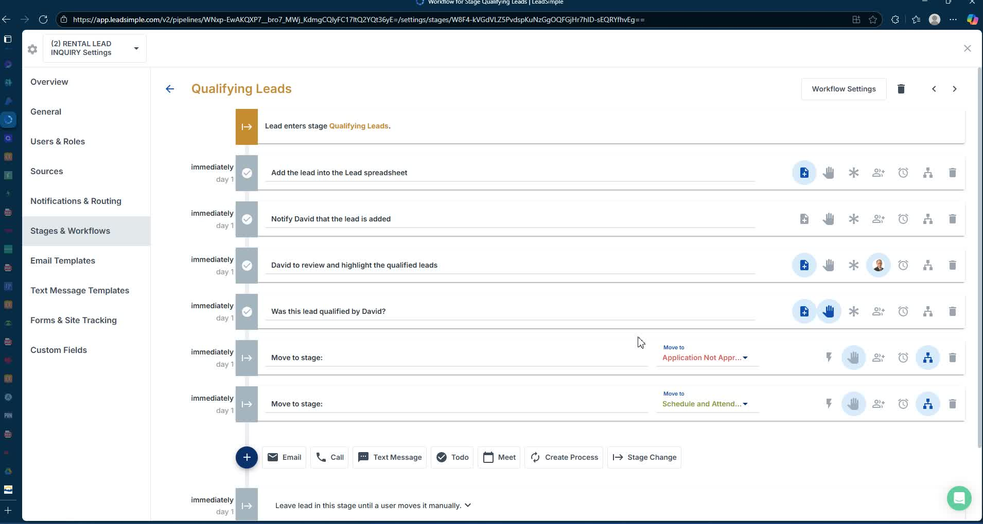
- Get Tenant Availability: Reach out to current tenants to confirm showing times.
- Confirm Appointments: Use templates to confirm showing dates and times with prospects.
6. Follow-Up After Showings 15:33
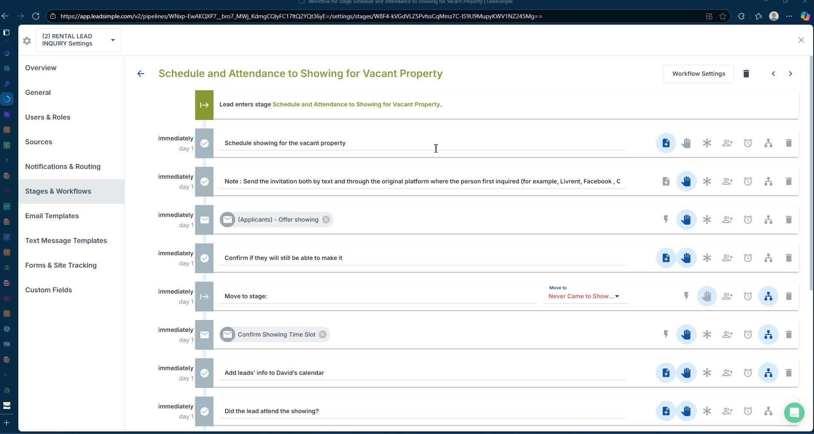
- Send Follow-Up Emails: Thank prospects for attending and provide application instructions.
- Application Submission: Include links for submitting applications and required documents.
7. Application Processing 22:10
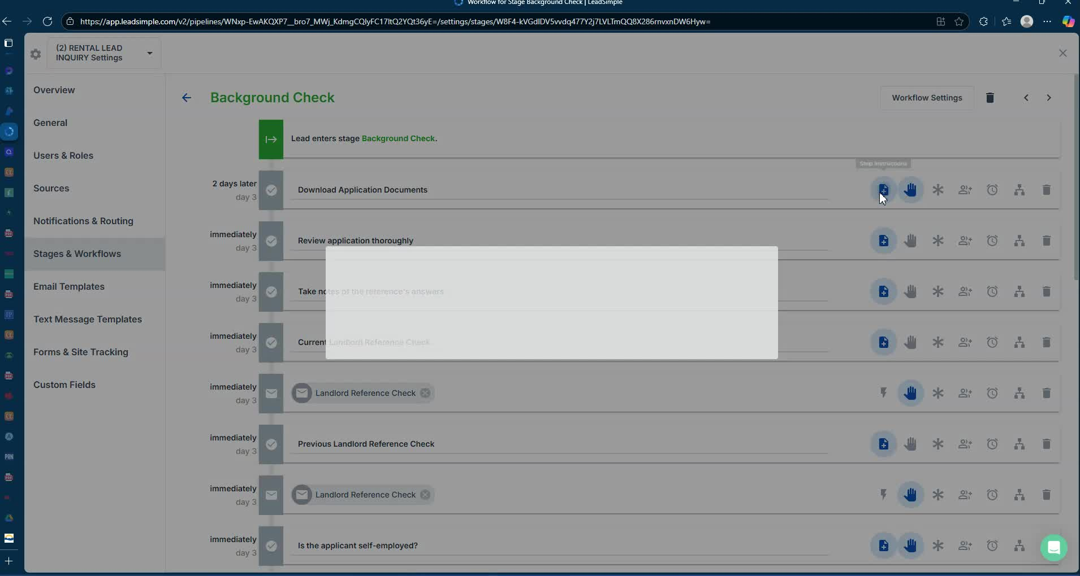
- Conduct Background Checks: Review submitted documents and perform background checks.
- Contact References: Reach out to previous landlords and employers for verification.
8. Owner Communication 38:02
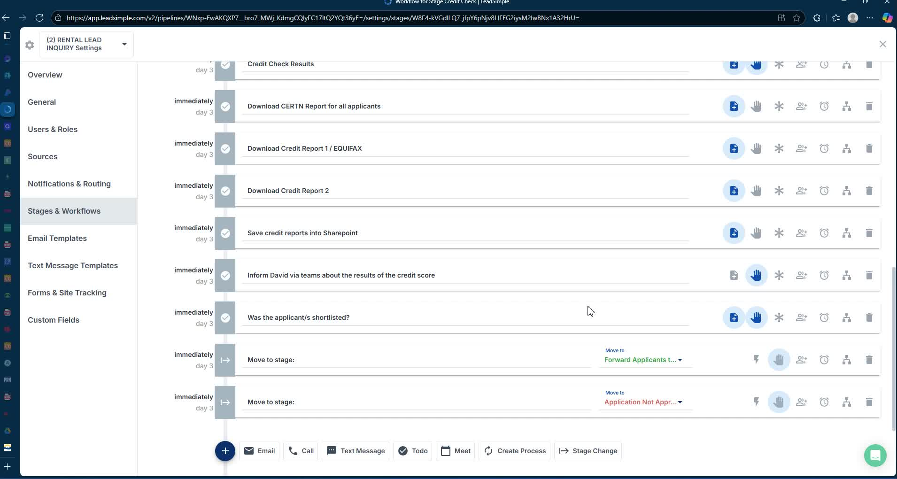
- Summarize Findings: Compile applicant details and send to the owner for decision-making.
- Notify Applicants: Inform applicants of approval or denial and request written confirmation.
9. Finalizing the Lease 41:08
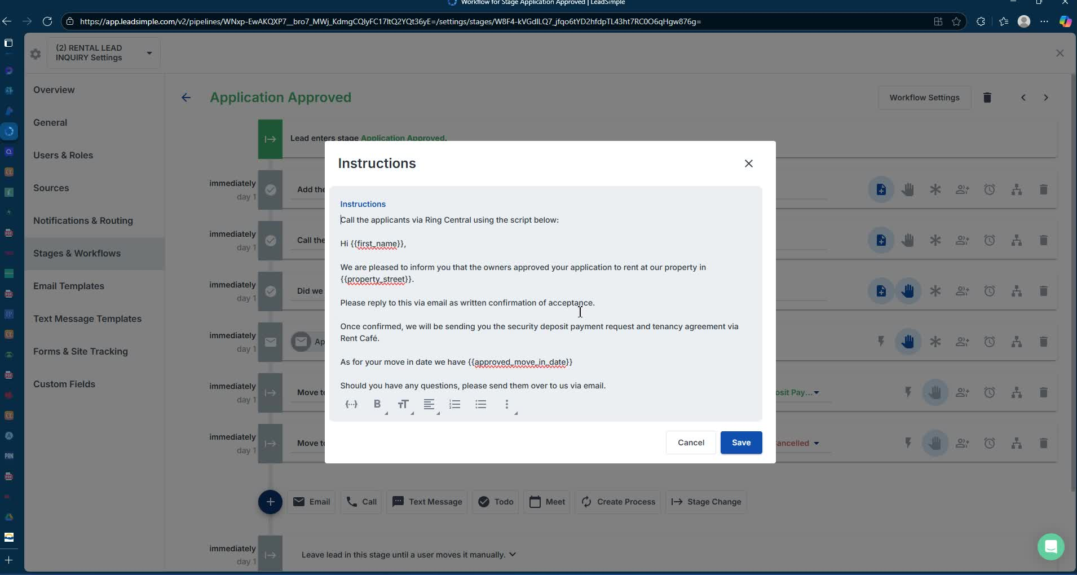
- Send Lease Documents: Prepare and send tenancy agreement and PAD form for signature.
- Collect Security Deposits: Ensure security deposits are processed correctly.
Cautionary Notes
- Do Not Respond to Non-Qualified Leads: Only respond to leads that answer the qualifying questions.
- Maintain Professionalism: Avoid discussing reasons for application denials to prevent potential disputes.
Tips for Efficiency
- Use Templates: Utilize email templates for responses and follow-ups to save time.
- Document Everything: Keep detailed notes on each applicant and communication for future reference.
- Automate Where Possible: Consider using software tools to streamline scheduling and application processing.
Link to Loom
https://loom.com/share/c5f9c735d90340e8a525ba469b1f9b8e

Rental Lead Inquiry Process

1. Initial Lead Handling 0:00

- Process to funnel rental leads from listings.
- Stages include:
  - All perspective inquiries
  - Qualifying leads
  - Scheduling showings
  - Handling tenant-occupied vs. vacant properties.

2. Pre-Qualification of Leads 1:04
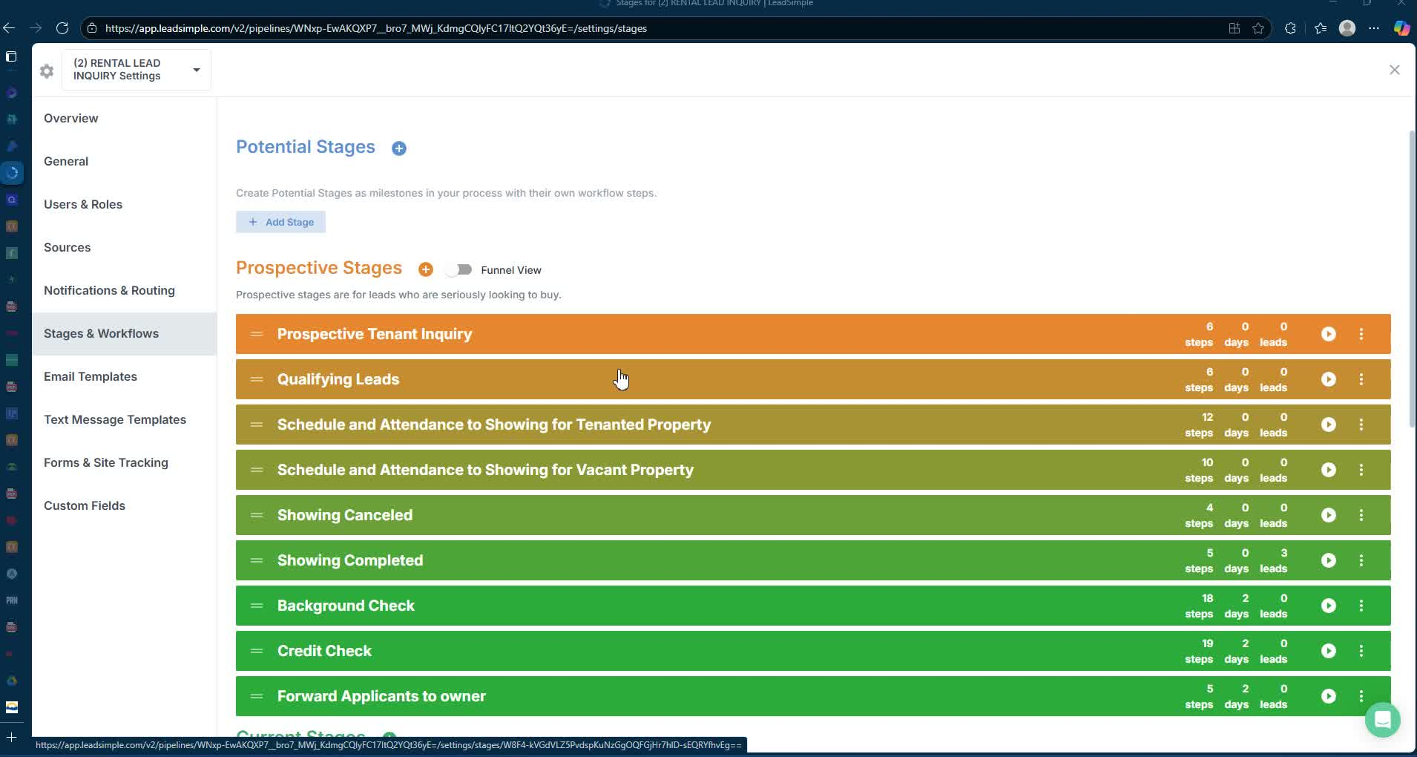
- Designed for property management assistants to provide clear support.
- Important notes:
  - Leads must answer two questions to receive a response:
    - Number of occupants
    - Occupations of all occupants.

3. Introduction and Pre-Screening 2:05
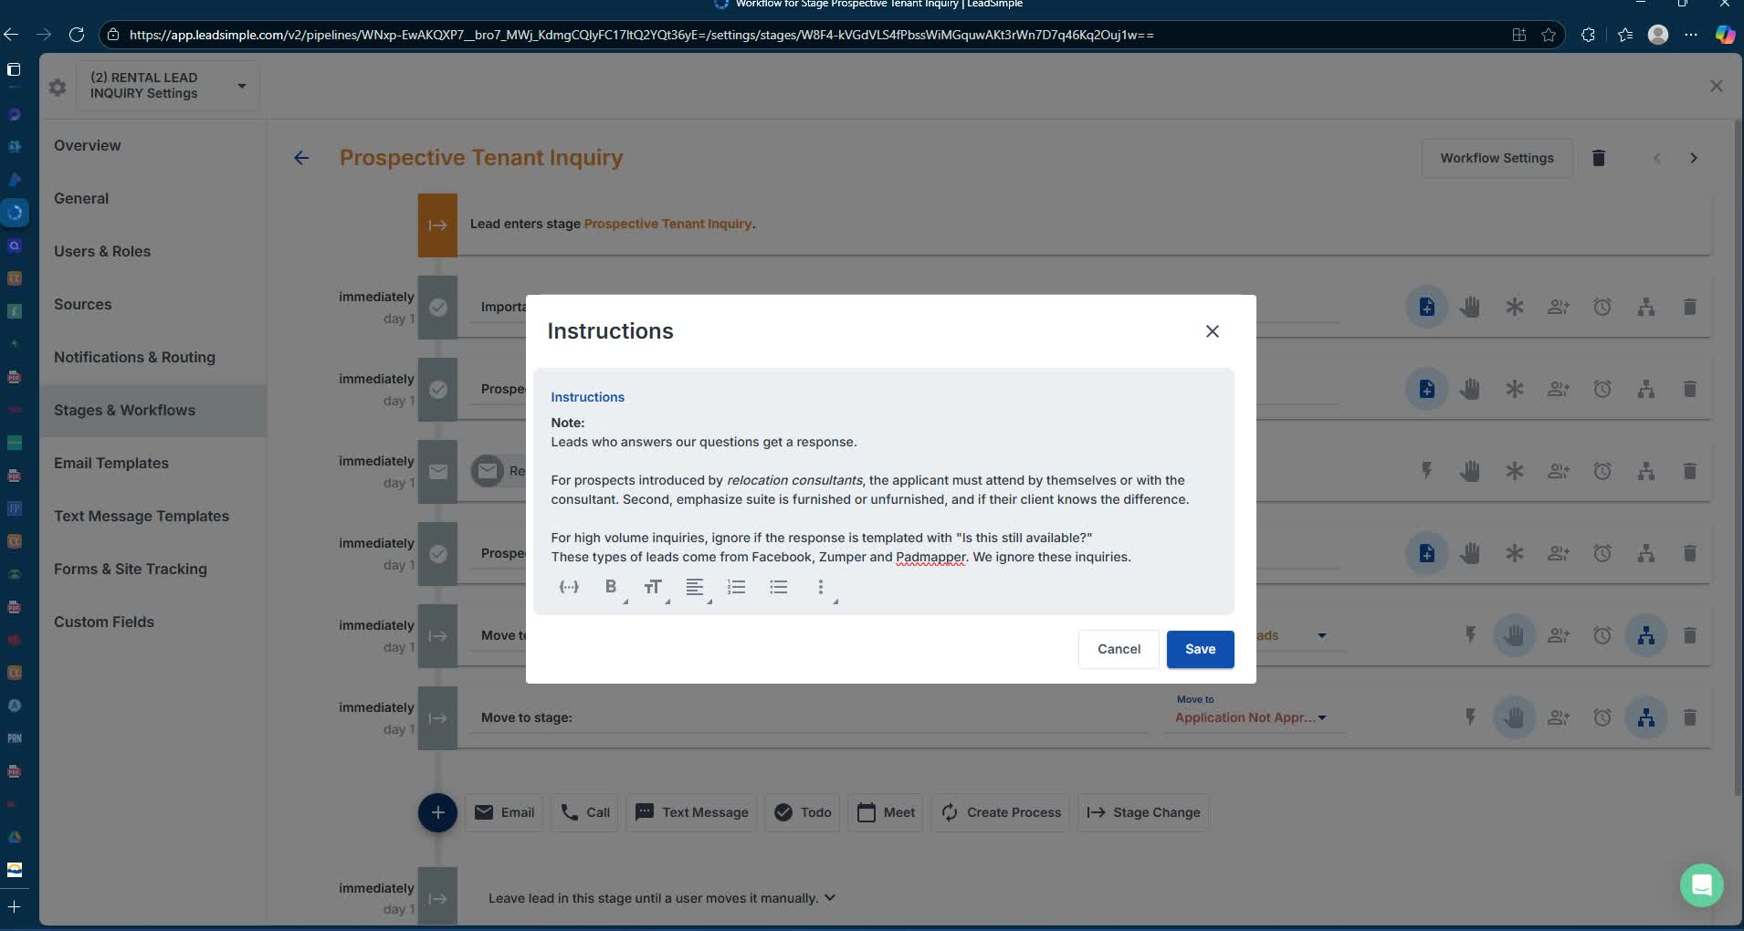
- Prospects introduced by relocation consultants are usually pre-qualified.
- Must attend showings themselves or with a consultant.

4. Responding to Inquiries 3:05
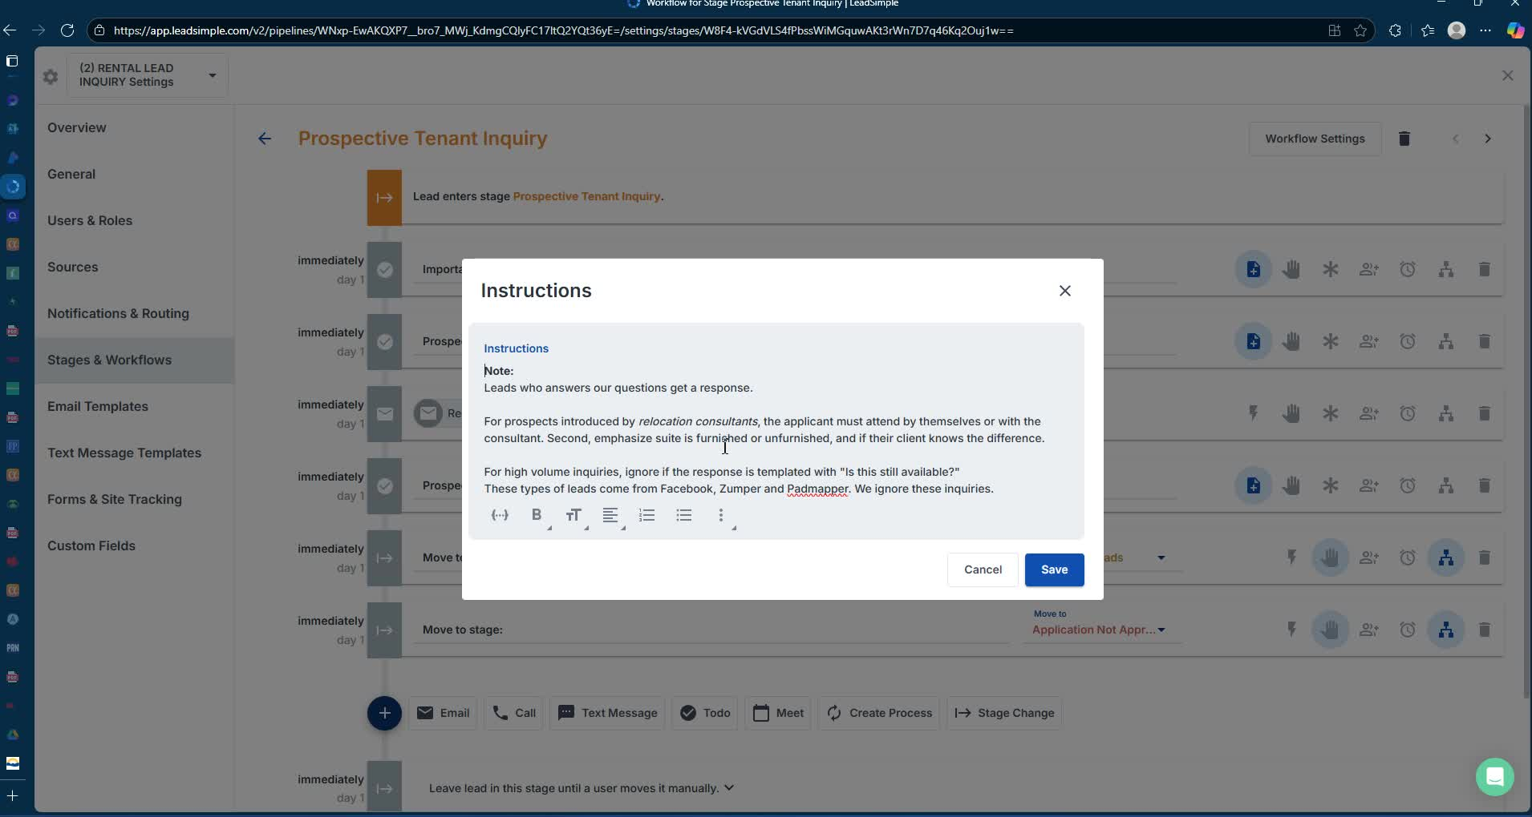
- Assistants must read responses carefully to avoid miscommunication.
- Key questions to ask:
  - Names of applicants
  - Occupation
  - Pet ownership
  - Reason for moving
  - Contact information.

5. Scheduling Showings 10:00
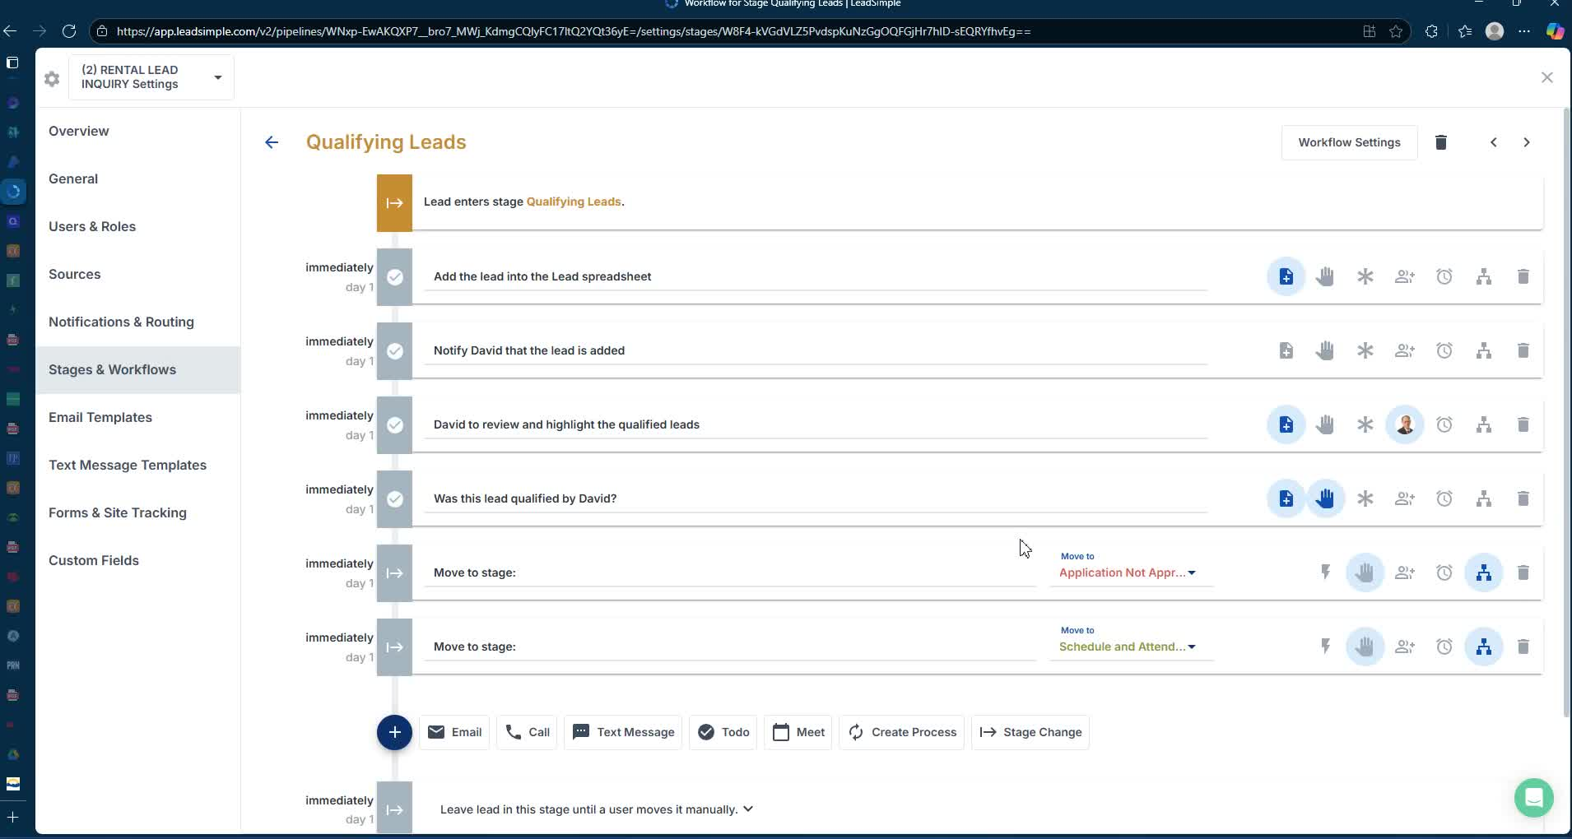
- Confirm tenant availability for occupied properties.
- Use templates to communicate with tenants and prospects.
- Document attendance and follow up with confirmations.

6. Conducting Showings 15:10

- Follow up with prospects after showings.
- Send thank-you emails and application instructions.

7. Application Submission 18:07
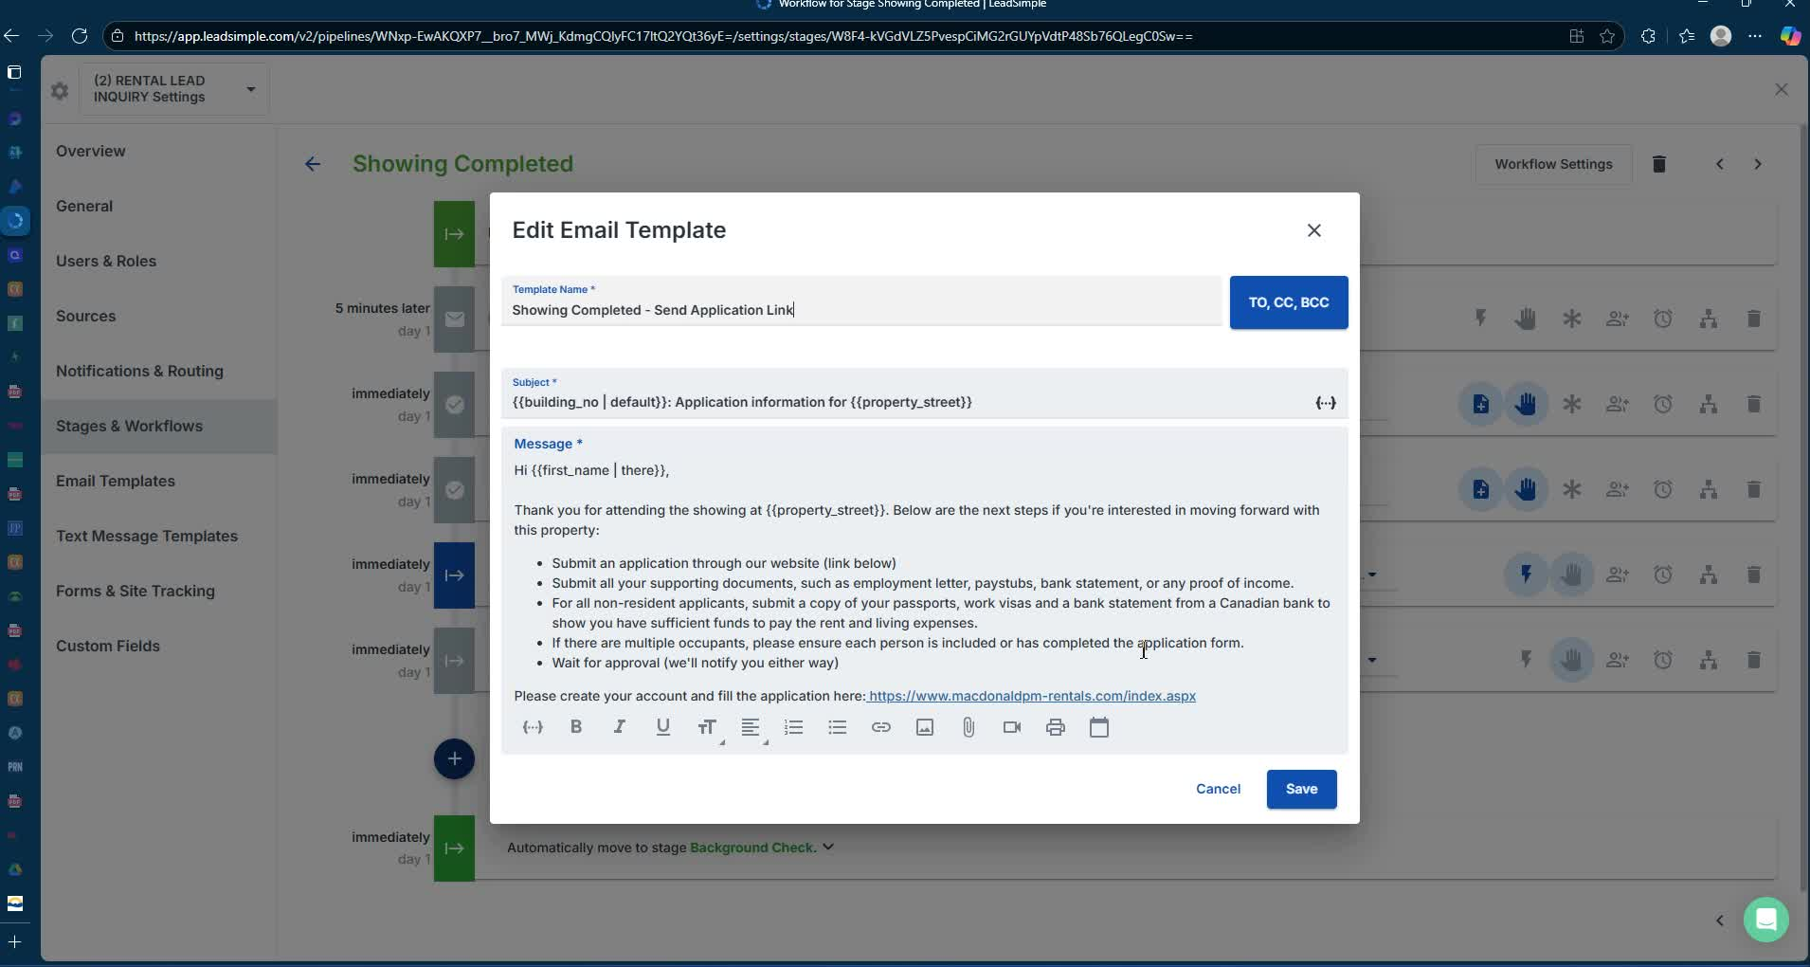
- Applicants submit applications online with supporting documents.
- Include instructions for non-resident applicants.

8. Background and Credit Checks 21:34
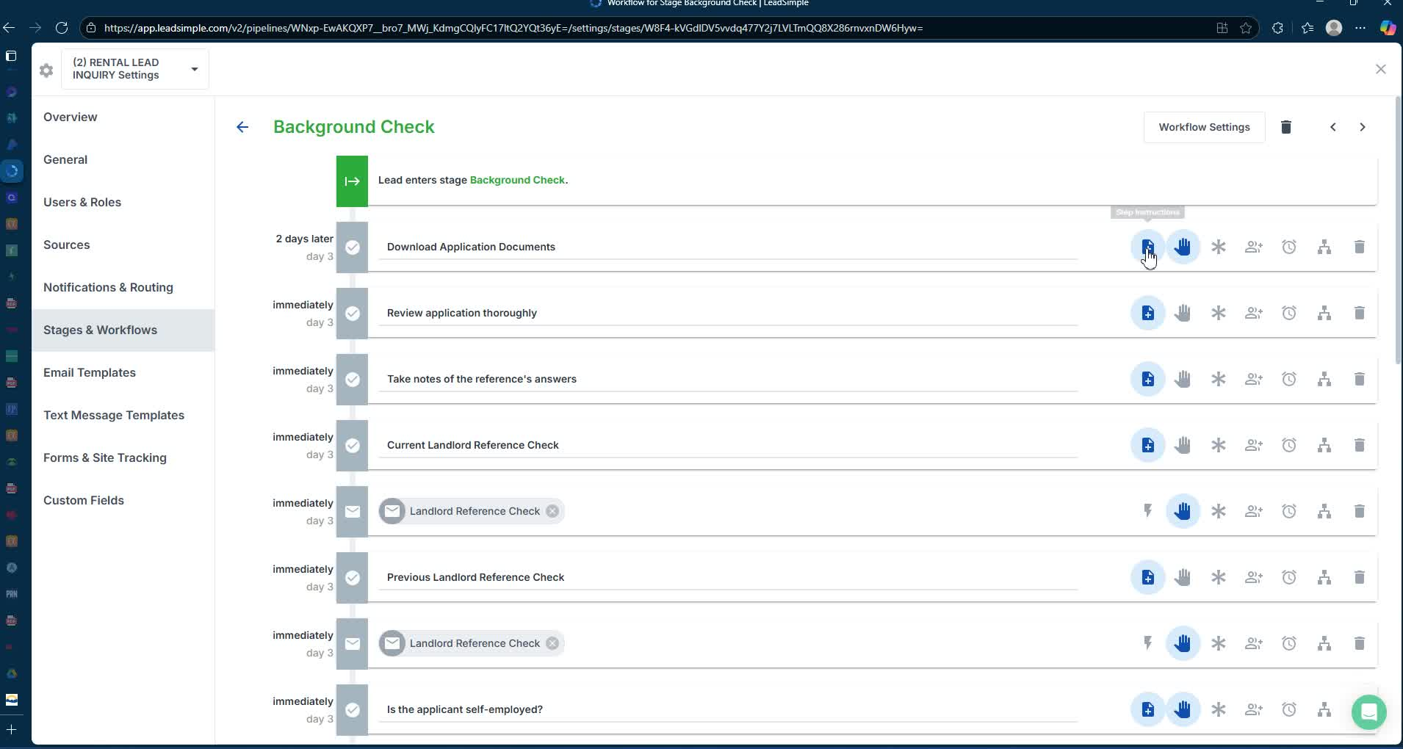
- Review submitted documents and conduct background checks.
- Contact previous landlords and employers for references.

9. Owner Recommendations 37:09
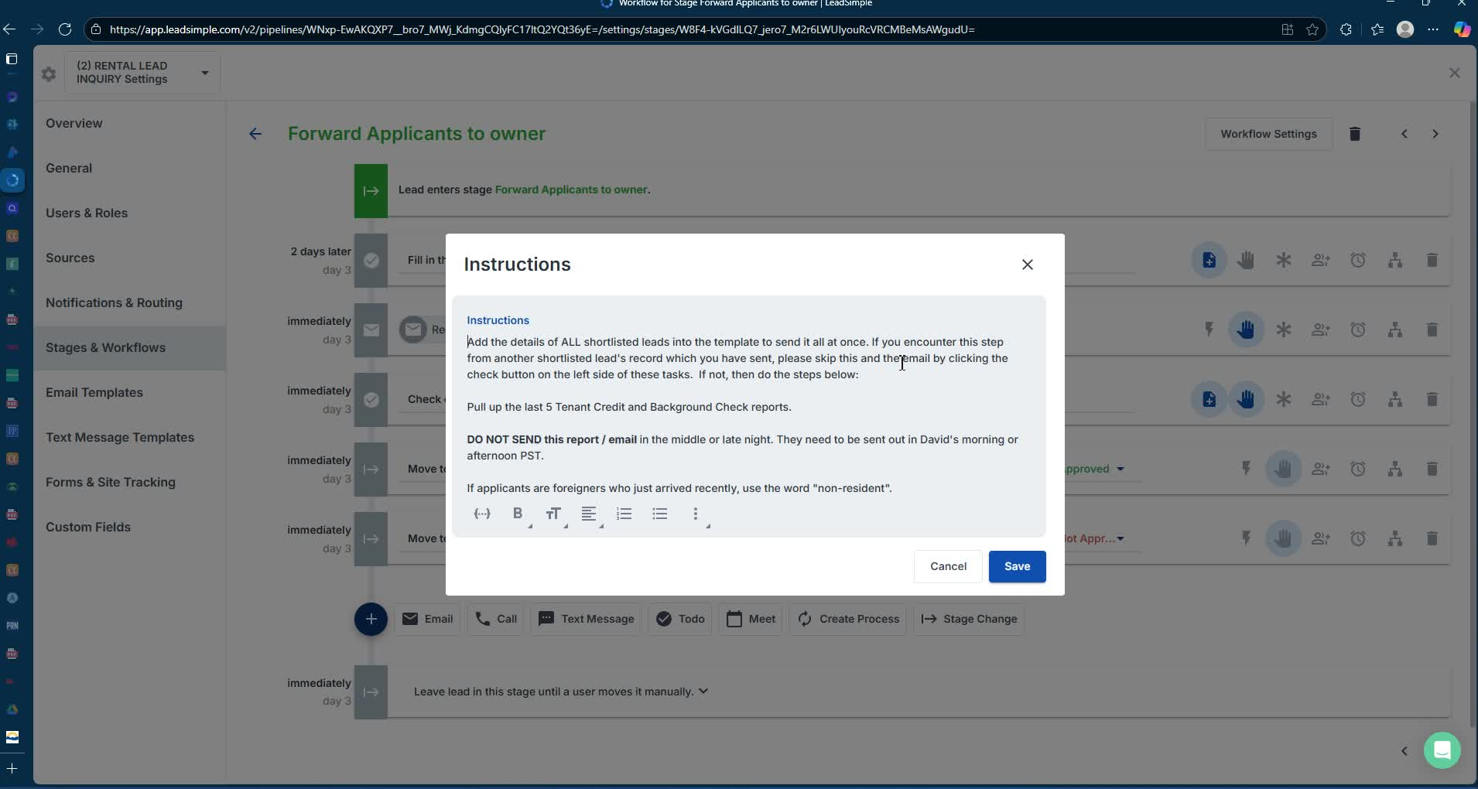
- Summarize findings and recommend shortlisted applicants to the owner.
- Ensure communication is professional and timely.

10. Finalizing Applications 39:30
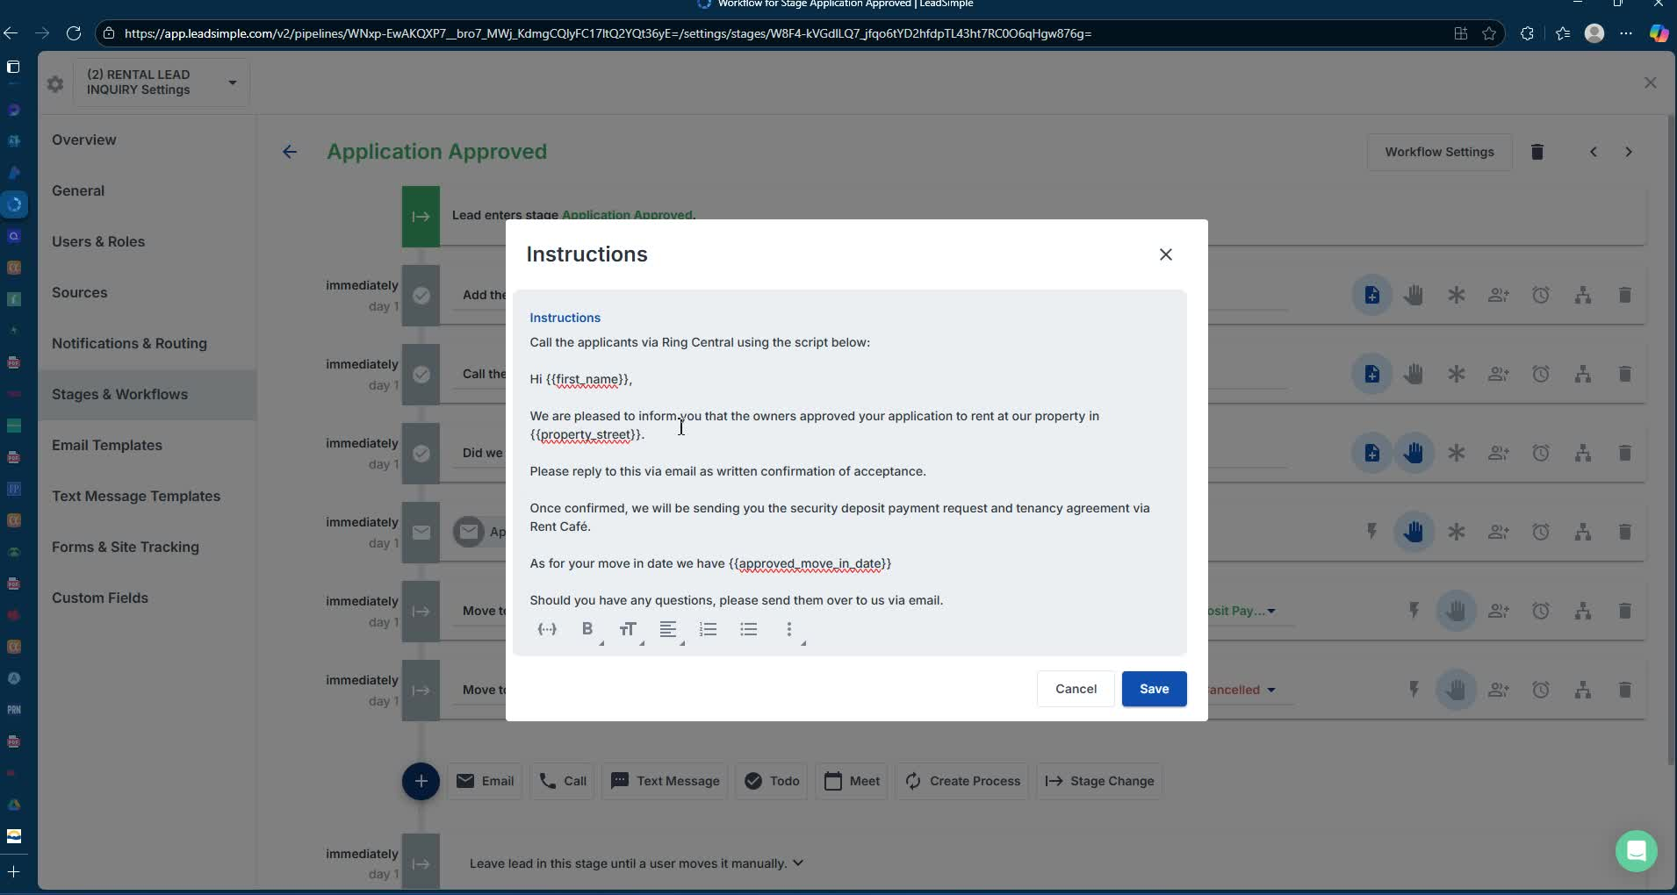
- Notify approved applicants and request written confirmation.
- Send tenancy agreement and payment instructions.

11. Handling Withdrawals and Denials 45:08
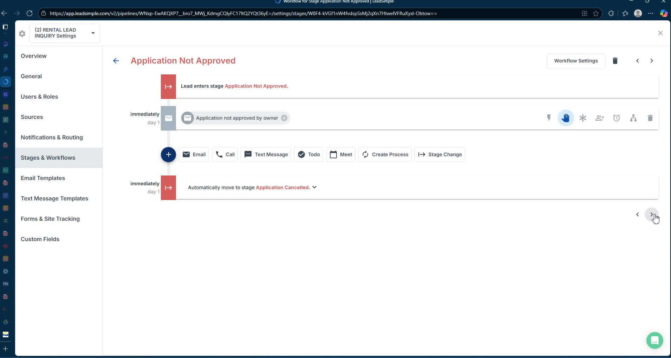
- Document and communicate any withdrawals or denials to applicants.
- Maintain professionalism and avoid unnecessary explanations.
Link to Loom
https://loom.com/share/c5f9c735d90340e8a525ba469b1f9b8e

Steps to Reproduce Rental Lead Inquiry Process

1. Initial Inquiry 1:29
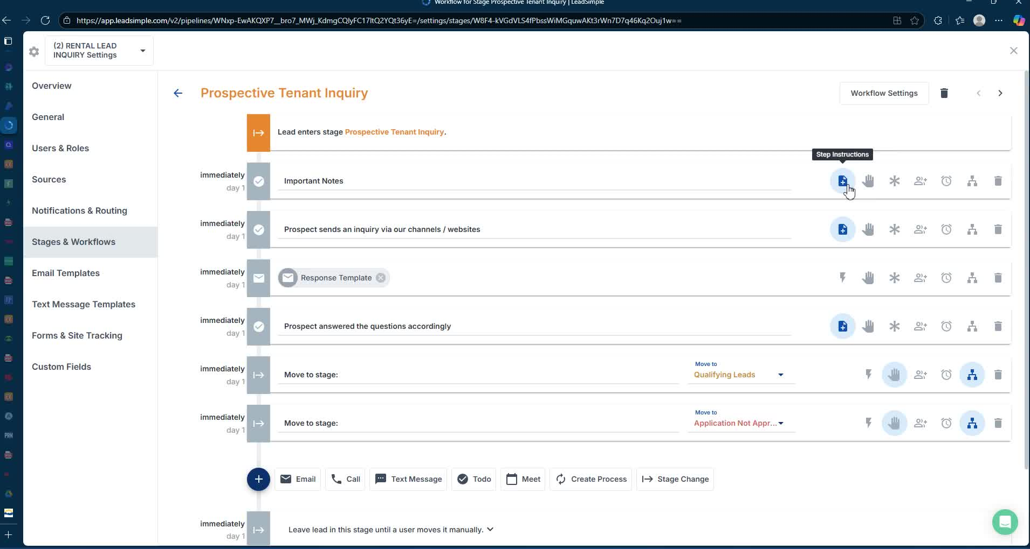
- Ensure leads answer two questions:
  - How many people will live with you?
  - What are your occupations?

2. Pre-Qualification 2:05

- Prospects should be introduced by relocation consultants or pre-screened.
- Confirm that they are ready to proceed with the application.

3. Lead Documentation 8:50
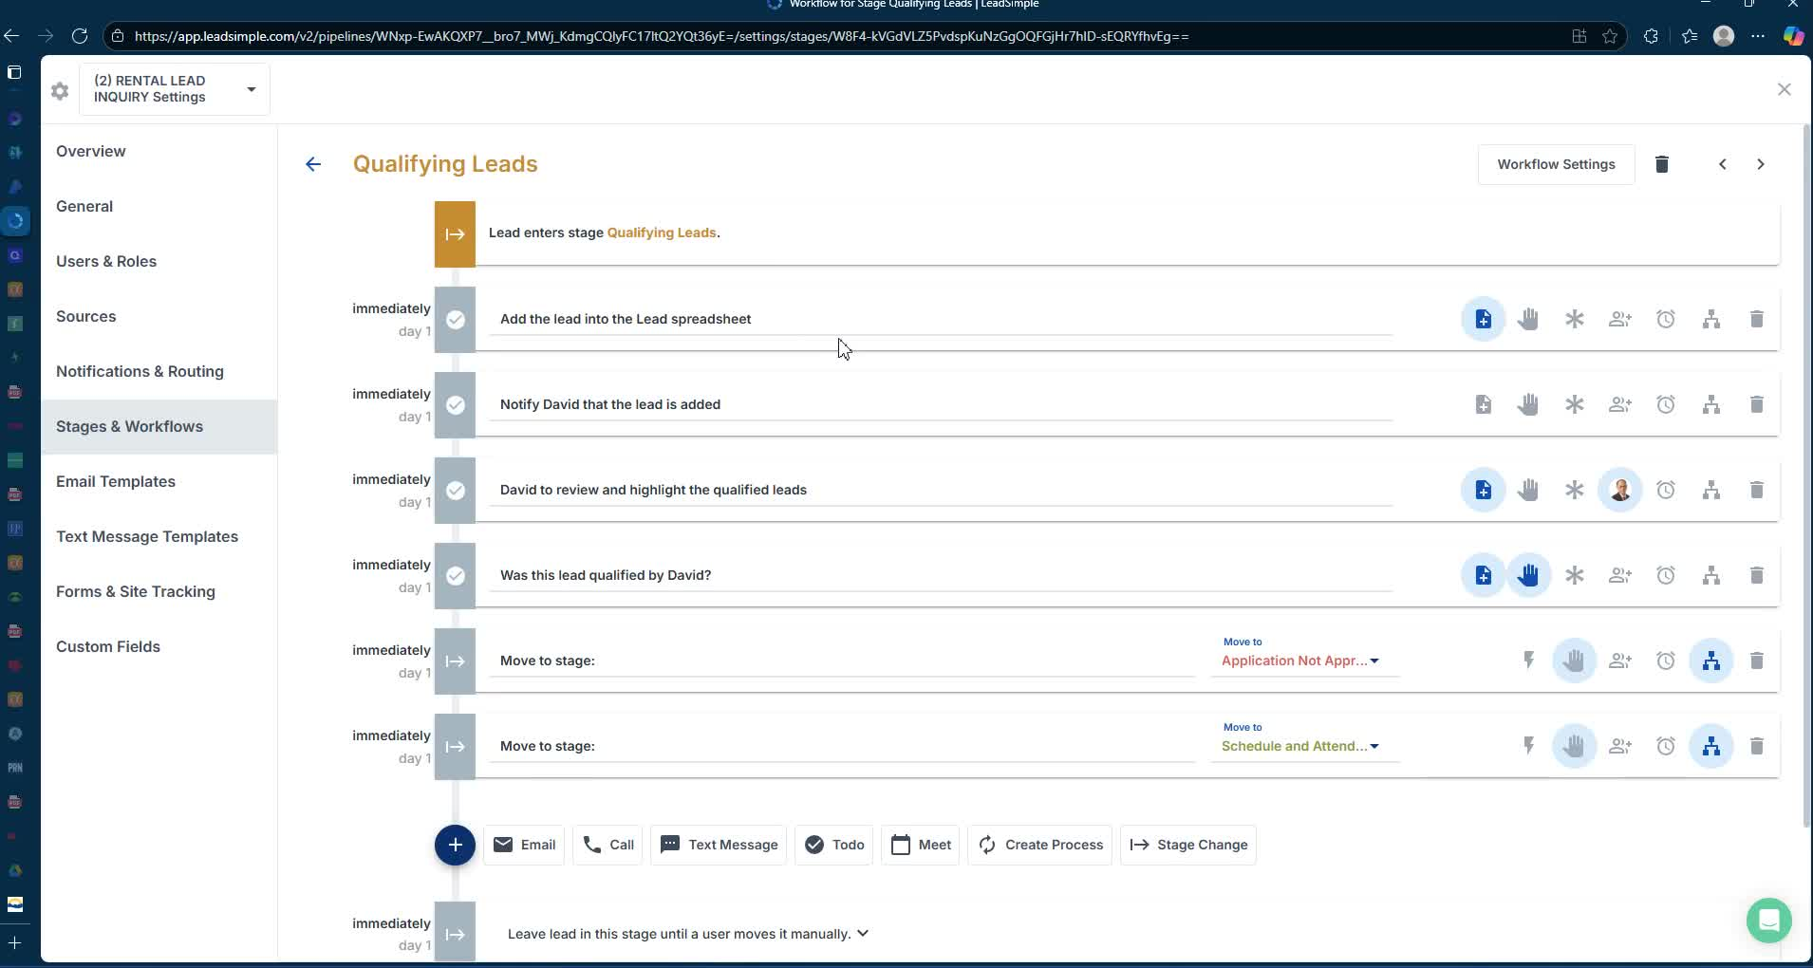
- Add the lead's contact information to the lead spreadsheet for review.

4. Schedule Showing for Tenant-Occupied Properties 10:21
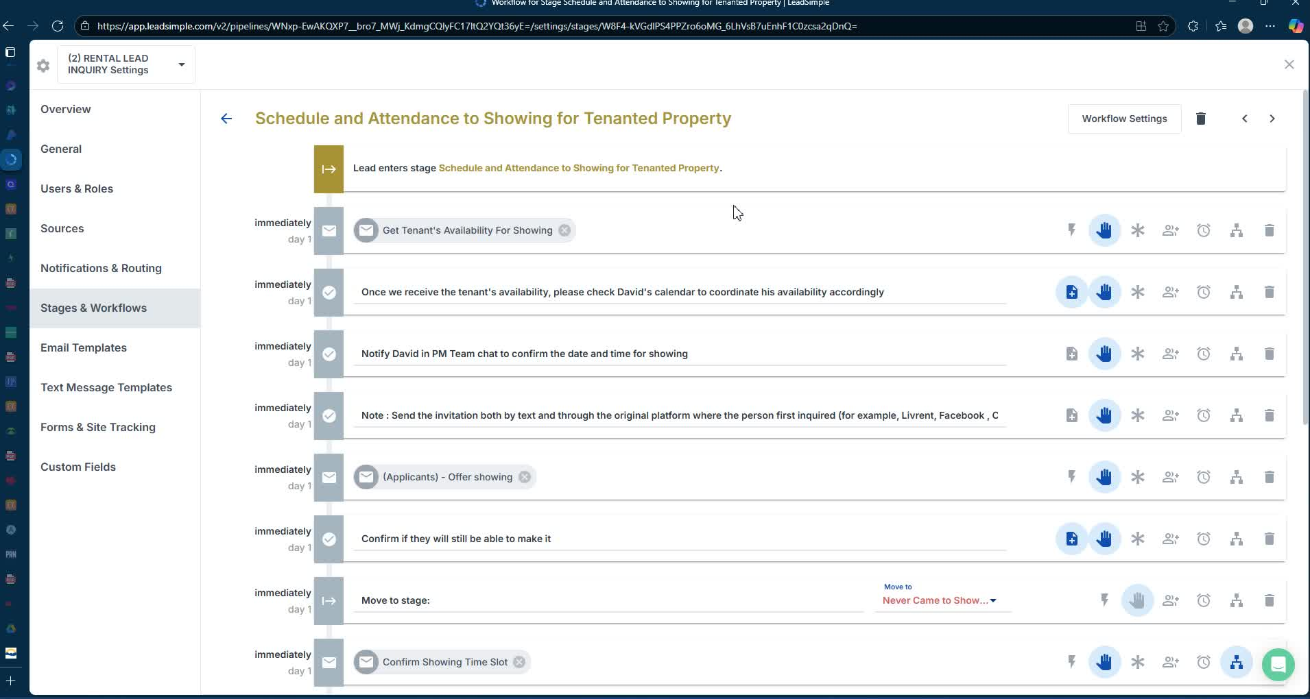
- Confirm tenant's availability for showing.
- Use a template to request showing confirmation from the tenant.

5. Confirm Showing Appointment 12:04
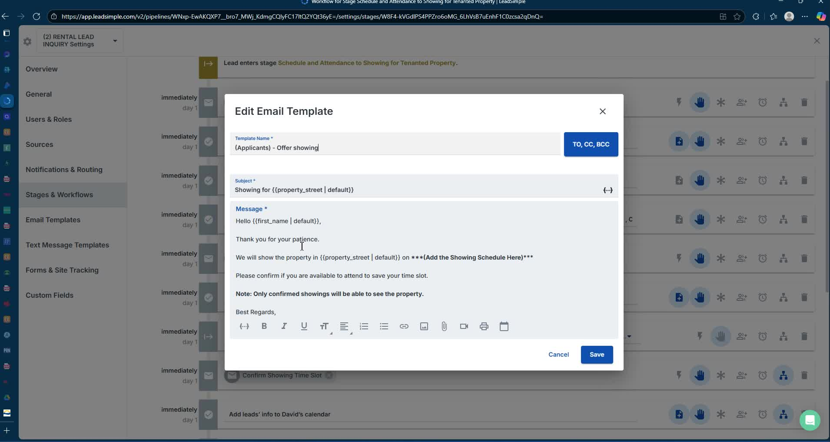
- Notify prospects of their scheduled showing time.
- Emphasize the importance of confirming attendance.

6. Follow-Up After Showing 15:10

- Send a follow-up email thanking them for attending the showing.
- Include application submission instructions and required documents.

7. Application Submission 18:07

- Instruct applicants to submit their application through the website.
- Ensure they provide all necessary supporting documents.

8. Background and Credit Checks 21:34

- Review submitted documents and conduct background checks.
- Verify employment and landlord references.

9. Owner Recommendation 37:09

- Summarize findings and recommend shortlisted candidates to the owner.

10. Notify Applicants of Decision 39:30

- Inform applicants of the owner's decision regarding their application.
Link to Loom
https://loom.com/share/c5f9c735d90340e8a525ba469b1f9b8e

